ALLOY IDENTIFICATION P.M.I. Positive Material Identification
ASTM DESIGNATION E 1476 CHEMICAL SPOT CHECKS
Simple test for identification of 316 alloy
Code 23.100 CELMO Reagent Molybdenum for AISI 304 vs 316

To distinguish between AISI 316 and 304 you only need one reagent and one step
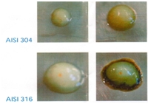
Apply a drop of solution to the (abraded) metal surface.
Leave for 1 – 5 minutes.
If it turns brown it is 316, no change then it is not 316.
Kit for approx. 550 tests (long shelf life)

