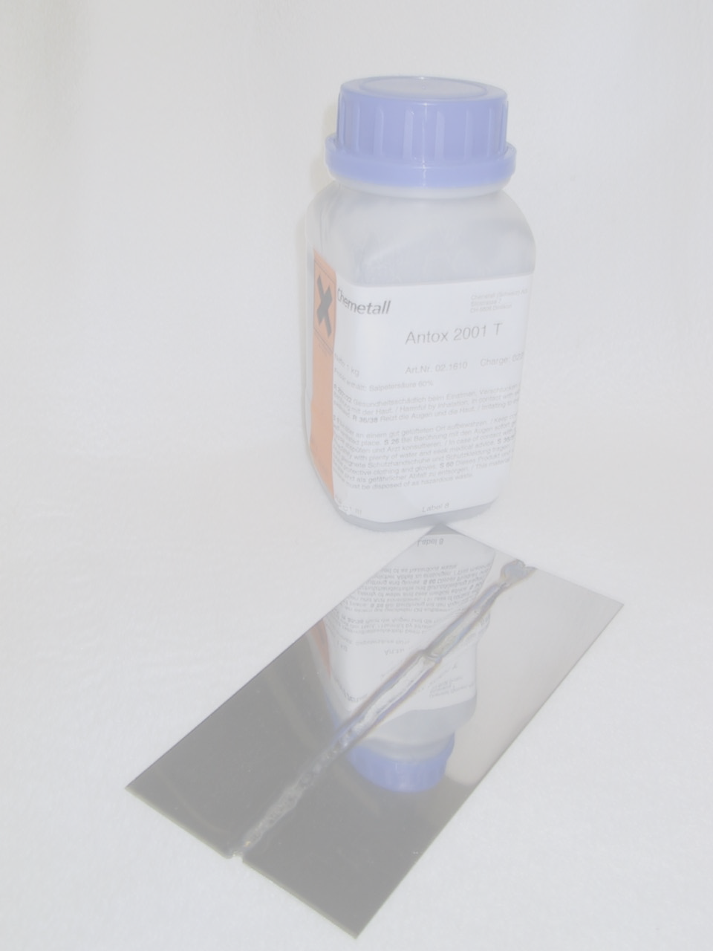
Antox 2001 T

Unique special product for the professional treatment of stainless steel!
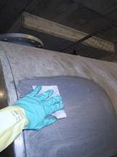
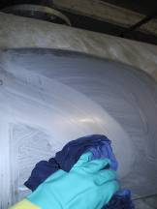
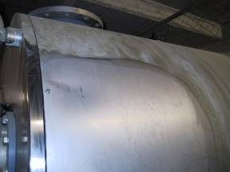

Removal of extreme contamination and rust spots on stainless steel surfaces

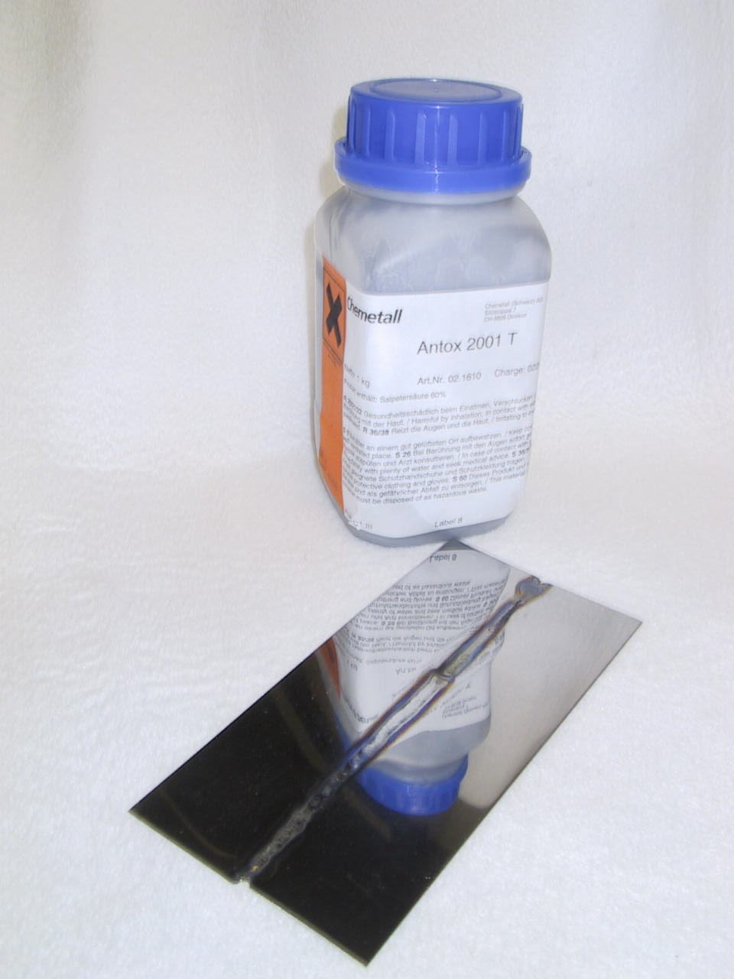
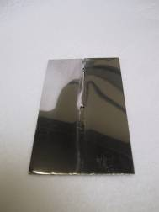

Pickling and cleaning of
TIG welding seams
on polished sheet

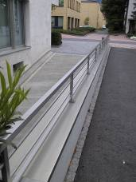

Pickling and cleaning of ground
and shiny stainless steel surfaces
without leaving white stains

Your local partner:

Read the Instruction Sheet and
MSDS before using Antox 2001T!

