30 NASMYTH ROAD SOUTH, COLQUHOUN PARK, HILLINGTON PARK, GLASGOW G52 4RE
ELMER WALLACE LIMITED
Tel: 0141 810 5530 Fax: 0141 810 5539 E-mail: sales@elmerwallace.co.uk Web: www.elmerwallace.co.uk

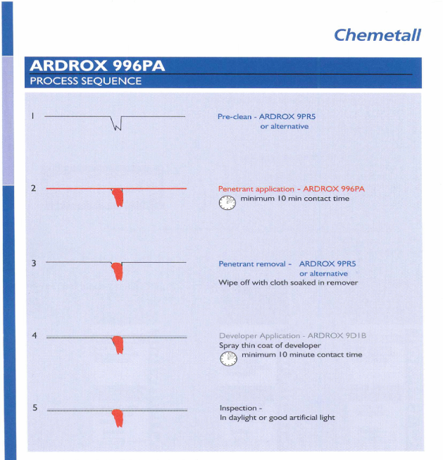
*Ardrox 996PA is now 996PB

