EASY- Point Tungsten Grinder
complete with dust extraction unit

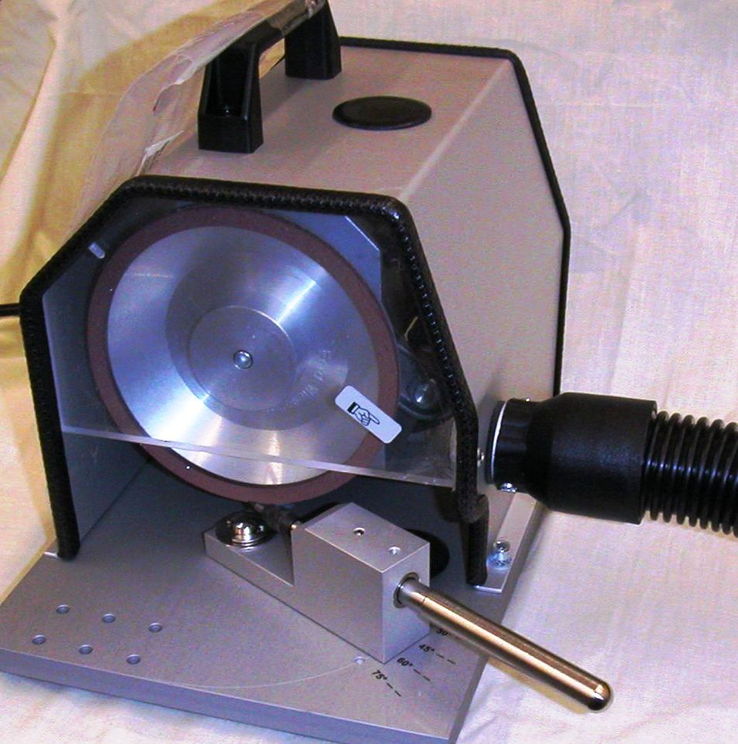

Thoriated Tungsten electrodes produce radio-active dust particles when ground. This dust is carcinogenic & can be hazardous to health with long term exposure. It is recommended that the dust is either contained or collected for disposal according to local regulations.
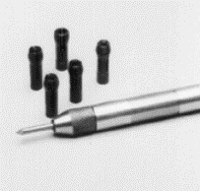
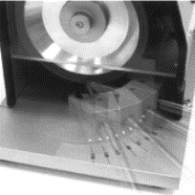

Collets & holder Setting the angle

