THE ISOJET-6 CLEANER
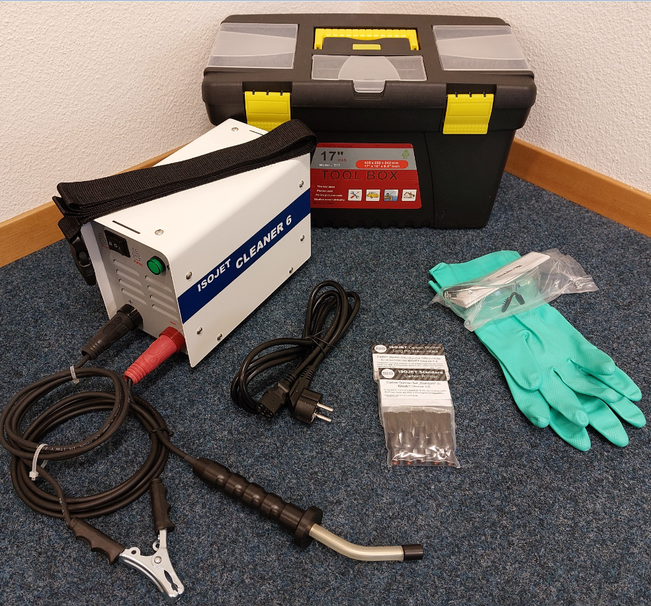
NEW CARBON BRUSH STAINLESS STEEL WELD CLEANING POLISHING & ETCHING MACHINE

The ISOJET-6 Cleaner has several advantages over normal pickling pastes for Welded seams and fillets: -

ISOJET-6 cleans and passivates stainless steel MIG & TIG welds by means of an instantaneous electrochemical reaction.
It does not leave shadows or “Halos”.

Cleaning and passivation are carried out instantly without the need to wait for pickling paste to react.

Isol-C cleaning solution does not contain any nasty Hydrofluoric, Nitric or Sulphuric Acids.

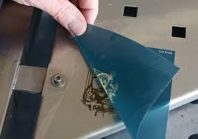
Neutraliser is supplied which means that waste pollutants are eliminated avoiding the expense of disposal or treatment processes.

ISOJET-6 unit can also be used for polishing areas by a simple switch. Etching of Stainless Steel can also be performed with Isol-ES solution.
Stencils can be produced from your artwork.

The system is portable enough to be taken to larger more complicated jobs.

IF YOU WOULD LIKE MORE INFORMATION OR TO ARRANGE A DEMONSTRATION PLEASE CONTACT YOUR LOCAL DEALER

