30 NASMYTH ROAD SOUTH, COLQUHOUN PARK, HILLINGTON PARK, GLASGOW G52 4RE
ELMER WALLACE LIMITED
Tel: 0141 810 5530 Fax: 0141 810 5539 E-mail: sales@elmerwallace.co.uk Web: www.elmerwallace.co.uk
POLAR-FLUX

- Formulated for inert-gas, metallic-arc, and/or gas welding of stainless steel, high chromium ferrous alloys, and low Nickel alloys.

- Provides significant protection and improves weld quality.

- Most cost-effective alternative for backside protection in lieu of Nitrogen, Argon, or other gases.

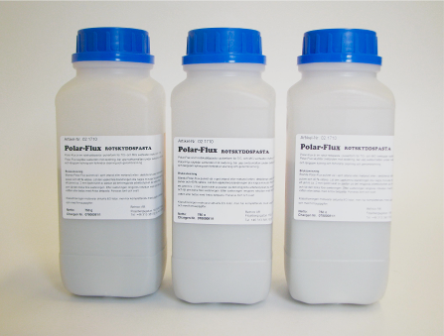
POLAR-FLUX

- Replaces root gas and backing bars
- Prevents oxide inclusions
- Protects the root side from oxidation
- Gives an even smooth bead
- Eliminate pore formation
- Prevents burn-through
- Saves shielding gases
- In powder form, just mix it with water or ethanol (Meths spirit)

POLAR-FLUX

Polar-Flux is formulated for Mig and Tig welding stainless steel and low nickel (less than 20%) heat resistant alloys. The flux prevents oxide inclusion formation, protects the backside from oxidation, supports the molten metal, and reduces burn-through. It is a more cost-effective means of achieving backside protection than other alternatives, including back-up bars, inert gas purge, back-up tape, and even other back-up fluxes. Additionally, the flux can be placed in areas where back-up bars or back-up tapes are impractical; such as parts with irregular shapes or bends.

POLAR-FLUX

Spot-welding:
Polar-Flux is applied to the surfaces of the joint before assembly. It works as a cleansing agent & prevents the formation of tempering oxides in the vicinity of the spot welds. This process eliminates the risk of contaminating the weld joint and allows the spot-weld to melt easily during the subsequent welding.

As a protective layer during welding:
Polar-Flux has several important functions when applied to the weld. The weld is protected against oxidation. The weld bead can be laid with a higher and constant speed. The flux’s moistening and supporting effects on the melt redirects the surplus heat from the local areas in the weld and thereby prevents uncontrolled penetrations and burn through. Even, uniform heating and the absence of contaminants prevent pinholes.

Overlapping welds:
Polar-Flux applied to the underside of overlaps prevents uncontrolled penetrations. Even heating and lower cooling speed prevents brittleness and gives stronger, more ductile welds.

Single-V-joints with different plate thickness:
Polar-Flux prevents burn-through when welding together thin and thick materials. Because the heat is evenly distributed local areas of high temperature are avoided and the welds penetrate uniformly.

Single-V-joints welded on one side:
Polar-Flux applied to the weld promotes even penetration with sufficient amount of material with initial bonding. Welds, which previously needed welding from both sides, can be effectively joined with a weld bead on one side.

Single-V-joints welded on both sides:
When joining thick plate, or where two-sided welding is necessary for quality’s sake, the flux should be applied to the weld before the first weld bead is laid. The even and strongly bound weld does not require chiselling or grinding. Brushing with a steel brush is recommended for removing slag remnants after the second weld bead.

Joining of low and high-alloy steel (composite steel):
When Polar-Flux is used the welder can bevel both the low alloyed and the high alloyed material prior to welding. This eliminates supplementary work with grinding and chiselling. When Polar-Flux is used with these alloys it should be applied to the high alloyed side and welded beginning with the low-alloyed side.

Polar-Flux is supplied in 500g tubs.

