LED UV (Blacklight) Lamp with spraying attachment

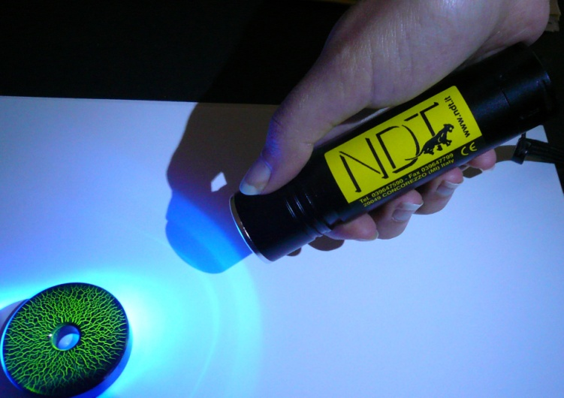
High intensity UV LED lamp (up to 7.000 μW/cm² at 38 cm/15 inches), with a very broad inspection area of over 10 cm (4 inches) diameter. Includes the one-operator spraying kit: one hand on the yoke and one hand to hold fluorescent spray can with integrated UV light:

Features:
- 1 high efficiency UV LED, Certified for wavelength of 365 (+5) nm
- Up to 50,000 hours LED bulb life: never change a UV lamp again!
- UV LED produce a very low visible light emission (< 2 foot candles / < 20 lx)
- Instant-on operation, LED reaches full intensity immediately
- Very light: 160 g; Dimensions: length 11 cm – diameter 2,8 cm
- According to: ASTM, ASME, AMS, ISO intensity specifications for fluorescent liquid
penetrants and magnetic particles inspection
- Safe Power Supply: Powered by n.3 rechargeable "AAA" batteries
- Battery charger with adapters for Car, USB socket or AC mains option

