PASSI TEST
- 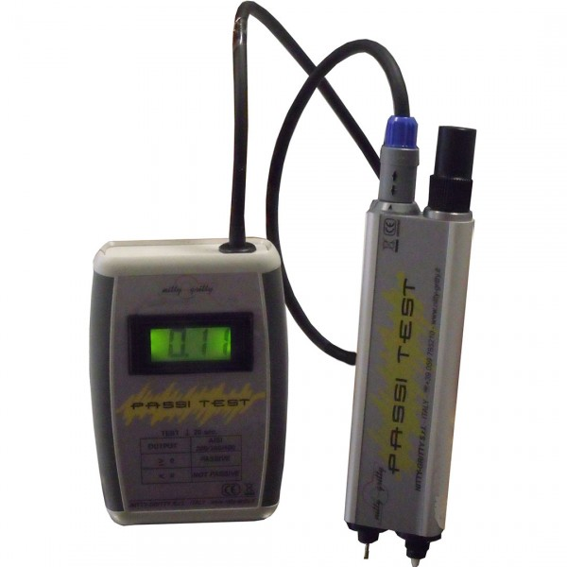

Passi Test is a tool designed for those who need to know accurately the passive condition of the stainless steel. It consists of a “probe pen” – which will be placed on the surface to be tested – connected to an electrochemical system and external reading unit.
Passi Test measures the open-circuit potential and the nobility of a metal (and consequently its resistance to corrosion). The test, which is non-destructive, nor damaging, is fast (the result is given in about 15 seconds) and numerical: while the other passivation tests, purely chemical, are based on the interpretation of a colour (ferroxyl test), thus offering a strongly subjective datum, often distorted by superficial impurities, Passi Test releases an exact and indisputable numerical value.
The Passi Test internal system is calibrated in such a way that the zero is the discriminating point: if the value is higher than zero, then the stainless steel is passivated, if the value is lower than zero, the passivation is either scarce or non-existent. As such, it is possible to compare different kinds of stainless steel: the higher than zero is the value, the better the passivation of the sample; the lower than zero is the value, the absence of any passivation of the tested stainless steel.
Passivation results can be influenced by surface contours, finish and impurities.
The cleaner, smoother and more highly polished the surface the better the results

