30 NASMYTH ROAD SOUTH, COLQUHOUN PARK, HILLINGTON PARK, GLASGOW G52 4RE
ELMER WALLACE LIMITED
Tel: 0141 810 5530 Fax: 0141 810 5539 E-mail: sales@elmerwallace.co.uk Web: www.elmerwallace.co.uk
TIG WAND RAPID

Adapter for DC Weld Cleaning
Extremely Fast Stainless Steel Weld Finishing

CONNECTS DIRECTLY TO A DC TIG WELDING UNIT

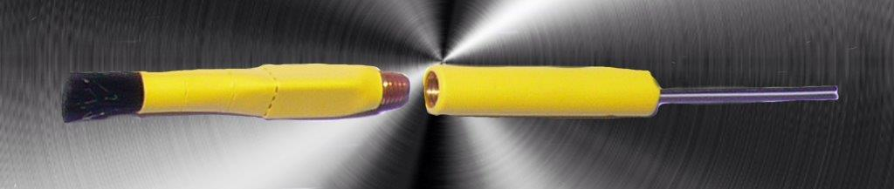

The DIRECT CURRENT means welds will be cleaned and
electro-polished resulting in a superior corrosive resistant post weld surface finish.
The patented adapter and unique brush design give a longer life and much faster cleaning speeds.
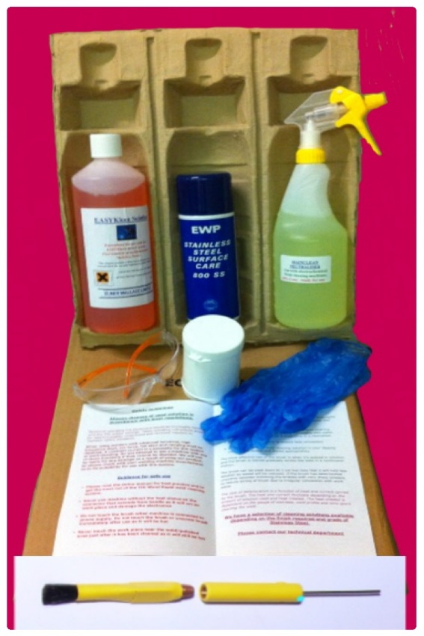
THE COMPLETE KIT CONTAINS

TIG Wand Adapter & Brush
1Litre Turbokleen Solution
500ml 10% Mainclean neutraliser
EWP 800SS Stainless Steel polish
Dipping container for Turbokleen
Safety Glasses & Gloves
Full instructions
Ready for connection & cleaning

30 NASMYTH ROAD SOUTH, COLQUHOUN PARK, HILLINGTON PARK, GLASGOW G52 4RE
ELMER WALLACE LIMITED
Tel: 0141 810 5530 Fax: 0141 810 5539 E-mail: sales@elmerwallace.co.uk Web: www.elmerwallace.co.uk
TIG WAND RAPID

Adapter for DC Weld Cleaning
Extremely Fast Stainless Steel Weld Finishing

CONNECTS DIRECTLY TO A DC TIG WELDING UNIT

The DIRECT CURRENT means welds will be cleaned and
electro-polished resulting in a superior corrosive resistant post weld surface finish.
The patented adapter and unique brush design give a longer life and much faster cleaning speeds.
THE COMPLETE KIT CONTAINS

TIG Wand Adapter & Brush
1Litre Turbokleen Solution
500ml 10% Mainclean neutraliser
EWP 800SS Stainless Steel polish
Dipping container for Turbokleen
Safety Glasses & Gloves
Full instructions
Ready for connection & cleaning

